**OMR SYSTEM ( QuickGRADE )**

Submitted in partial fulfillment of the requirements of the degree of

BACHELOR OF COMPUTER ENGINEERING

by

Savinay Pandey- 21102125

Pranav Patil - 21102180

Gautam Pandey - 21102117

Pratik Patil - 21102099

Guide:

Prof. H.S. BHUWAD



Department of Computer Engineering A. P. SHAH INSTITUTE OF TECHNOLOGY, THANE (2023-2024)

A. P. SHAH INSTITUTE OF TECHNOLOGY, THANE

**CERTIFICATE**

This is to certify that the Mini Project 2A entitled “**OMR SYSTEM**” is a bonafide work of **Savinay Pandey (21102125), Pranav Patil (21102180),**

**Gautam Pandey (21102117), Pratik Patil (21102099)** submitted to the

University of Mumbai in partial fulfillment of the requirement

for the award of the degree of **Bachelor of Engineering** in **Computer Engineering.**

Guide:

Prof. H.S. Bhuwad

Project Coordinator:

Prof. D.S. Khachane

Head of Department Prof. S.H. Malave

• A. P. SHAH INSTITUTE OF TECHNOLOGY, THANE

Project Report Approval for Mini Project-2A

This project report entitled “**OMR SYSTEM*”*** by ***Savinay Pandey, Pranav Patil, Gautam Pandey, Pratik Patil*** is approved for the partialfulfillment of the degree of ***Bachelor of Engineering*** in ***Computer Engineering***, ***2023-24***.

Examiner Name Signature

1.

2.

Date:

Place:

**Declaration**

We declare that this written submission represents my ideas in my own words and where others' ideas or words have been included, I have adequately cited and referenced the sources. I also declare that I have adhered to all principles of academic honesty and integrity and have not misrepresented or fabricated or falsified any idea/data/fact/source in my submission. I understand that any violation of the above will be cause for disciplinary action by the Institute and can also evoke penal action from the sources which have thus not been properly cited or from whom proper permission has not been taken when needed.



Savinay Pandey-21102125



Pranav Patil-21102180



Gautam Pandey-21102117



Pratik Patil-21102099

Date:

**Abstract**

The OMR System website presents a groundbreaking approach to Optical Mark Recognition (OMR) technology, offering a versatile and accessible solution for assessments and data collection. This innovative platform allows users to scan and grade OMR sheets using the cameras of their mobile devices, eliminating the need for costly dedicated scanners and specialized forms.

One of the system's key features is its mobile scanning capability, enabling users to capture OMR sheets from anywhere, providing unmatched flexibility. Real-time grading ensures instant feedback and results, significantly reducing the time required for assessments. Moreover, the Mobile OMR System is cost-effective, effectively reducing the financial burden associated with traditional OMR solutions.

The user-friendly interface makes it accessible to a wide range of users, from educators to survey organizers. Stringent data security measures are in place to safeguard sensitive information throughout the scanning and grading process. The system's versatility extends across various domains, from education to market research, catering to diverse needs.

Customizable reports offer detailed insights, allowing for comprehensive data analysis, marking a substantial advancement in assessment and data collection technology. The Mobile OMR System redefines the OMR landscape, democratizing this technology, making it affordable, convenient, and adaptable for users across different sectors. It signifies a transformative paradigm shift in the world of OMR technology, expanding horizons for assessment and data collection.

**Keywords:**

**Mobile Scanning , Instant Grading , Cost-Efficiency , User-Friendly Interface , Data Security**

i

**CONTENTS**

|  |  |  |
| --- | --- | --- |
| **Sr No.** | **Chapter Name** | **Page No.** |
|  |  |  |
| **1** | **Introduction** | 1 |
|  |  |  |
| **2** | **Literature Survey** | 2 |
|  |  |  |
| **3** | **Problem Statement, Objective & Scope** | 5 |
|  |  |  |
| **4** | **Proposed System** | 7 |
|  |  |  |
| **5** | **Project Plan** | 13 |
|  |  |  |
| **6** | **Experimental Setup** | 14 |
|  |  |  |
| **7** | **Implementation Details** | 15 |
|  |  |  |
| **8** | **Results** | 19 |
|  |  |  |
| **9** | **Conclusion** | 23 |
|  |  |  |
| **10** | **References** | 24 |
|  |  |  |

ii

**LIST OF FIGURES**

|  |  |  |  |
| --- | --- | --- | --- |
| **Sr No.** | **Figure Name** | **Page No.** |  |
|  |  |  |  |
| **1** | **Architecture Diagram** | 07 |  |
|  |  |  |  |
| **2** | **DFD (Level 0)** | 08 |  |
|  |  |  |  |
| **3** | **DFD (Level 1)** | 08 |  |
|  |  |  |  |
| **4** | **DFD (Level 2)** | 09 |  |
|  |  |  |  |
| **5** | **Use-case Diagram** | 10 |  |
|  |  |  |  |
| **6** | **Sequence Diagram** | 11 |  |
|  |  |  |  |
| **7** | **Activity Diagram** | 12 |  |
|  |  |  |  |
| **8** | **Gantt chart** | 13 |  |
|  |  |  |  |
| **9** | **LOGIN / SIGNUP Page** | 19 |  |
|  |  |  |  |
| **10** | **Login validation** | 19 |  |
|  |  |  |  |
| **11** | **Preprocessing Backend (Tkinter)** | 20 |  |
|  |  |  |  |
| **12** | **Tkinter Final Grading** | 20 |  |
|  |  |  |  |
| **13** | **User- Input** | 21 |  |
|  |  |  |
| **14** | **Download Button And File Name PopUp** | 21 |  |
|  |  |  |  |

iii

**Chapter 1**

**Introduction**

The Mobile OMR System represents a revolutionary leap in the world of Optical Mark Recognition (OMR) technology, offering an innovative and user-friendly solution for assessments and data collection. This platform leverages the ubiquity and power of mobile devices, enabling users to scan and grade OMR sheets with the simplicity of their smartphone cameras. By doing so, it eliminates the need for expensive dedicated OMR scanners and specialized forms, ushering in a new era of accessibility and convenience.

Traditional OMR technology, with its associated hardware and infrastructure, has often been prohibitively expensive and limited in its use cases. The Mobile OMR System disrupts this paradigm by providing mobile scanning capabilities. Now, users can capture OMR sheets from virtually anywhere, with the flexibility to conduct assessments on the go.

A hallmark feature is the system's ability to provide instant grading, a game-changer in time-sensitive scenarios. This real-time processing allows educators, examiners, and survey organizers to obtain immediate feedback and results, greatly expediting the assessment process. Moreover, the system is remarkably cost-effective, as it obviates the need for investing in dedicated OMR scanning equipment.

The user interface is designed to be intuitive, ensuring that users from various backgrounds can seamlessly integrate the Mobile OMR System into their workflow. Stringent data security measures are in place to safeguard the confidentiality and integrity of sensitive information throughout the scanning and grading process.

This platform's versatility is a key asset, making it applicable across a broad spectrum of domains, from education to market research. Customizable reports provide in-depth insights, enabling users to analyze and interpret data comprehensively. The Mobile OMR System is more than just a technological advancement; it is a transformative shift, democratizing OMR technology, and making it affordable, convenient, and adaptable for users in diverse sectors. It landscape of OMR technology, expanding the horizons of assessment and data collection.

1

**Chapter 2**

**Literature Survey**

1. "A Survey of Optical Mark Recognition (OMR) Techniques" Authors: R. Sinha, A. K. Sharma, S. Arora

Published in: International Journal of Computer Applications (2012)

The paper provides a comprehensive overview of OMR techniques, including pre-processing, feature extraction, and classification methods. It emphasizes the importance of OMR in education and data collection and discusses challenges such as skew handling and noise reduction.

* 1. "Automatic OMR Grading Using Convolutional Neural Networks"

Authors: M. Zahid Hossain, S. M. Kamruzzaman

Published in: International Journal of Advanced Computer Science and Applications (2017) The authors propose a CNN-based OMR system that achieves high accuracy in grading. They highlight the potential of deep learning techniques in OMR recognition and its applicability in various domains.

* 1. "A Survey on OMR Technologies" Authors: K. Suresh, P. Geetha, P. Kavitha

Published in: International Journal of Computer Applications (2013)

This survey paper provides a detailed overview of OMR technologies and their applications in various fields. It discusses the challenges in OMR recognition and the evolution of OMR systems over time.

1. "OMR Reader: An Optical Mark Recognition System"

Authors: M. S. Hasan, M. Y. Mashor, K. C. Low

Published in: International Journal of Machine Learning and Computing (2013)

The authors present an OMR system capable of processing large-scale exam sheets efficiently. They discuss the system's advantages, including speed and accuracy, and its potential applications in educational institutions.

2

1. "An Efficient OMR Grading System Based on Image Processing and Artificial Intelligence"

Authors: S. N. Al-Ashraf, M. A. El-Bendary, S. M. El-Khair, et al.

Published in: 2020 IEEE/RSJ International Conference on Intelligent Robots and Systems (IROS)

The authors present an OMR grading system using image processing and AI techniques. The system offers high accuracy in grading and can be applied to various types of forms.

1. "A Review on Optical Mark Recognition (OMR) Technology and its Applications" Authors: P. K. Jain, A. Jain

Published in: International Journal of Advanced Research in Computer Science and Software Engineering (2013)

This review discusses OMR technology and its diverse applications in detail. It emphasizes the need for efficient OMR systems in educational institutions and surveys different techniques used in OMR recognition.

These papers provide a solid foundation for understanding the current state of OMR recognition systems, their applications, and the latest advancements in the field. Be sure to access the full papers for more in-depth information and insights. Additionally, you may want to explore more recent research articles to stay up-to-date with the latest developments in OMR technology.

3

Table no. 2.1 : Literature Survey

|  |  |  |  |  |
| --- | --- | --- | --- | --- |
| Paper | Authors | Published in |  | Analysiss |
|  |  |  |  |  |
| A Survey of | R. Sinha, A. K. | International |  | The paper provides a |
| Optical | Sharma, S. | Journal of |  | comprehensive overview |
| Mark | Arora | Computer |  | of OMR techniques, |
| Recognition |  | Applications |  | including preprocessing, |
| (OMR) |  | (2012) |  | feature extraction, and |
| Techniques |  |  |  | classification methods. |
| Automatic | M. Zahid | International |  | The authors propose a |
| OMR | Hossain, | Journal of |  | CNNbased OMR system |
| Grading | S. M. | Advanced |  | that achieves high |
| Using | Kamruzzaman | Computer |  | accuracy in grading. |
| Convolutional |  | Science and |  |  |
| Neural |  | Applications |  |  |
| Networks |  | (2017) |  |  |
| A Survey on | K. Suresh, P. | International |  | This survey paper |
| OMR | Geetha, P. | Journal of |  | provides a detailed |
| Technologies | Kavitha | Computer |  | overview of OMR |
|  |  | Applications |  | technologies and their |
|  |  | (2013) |  | applications in various |
|  |  |  |  | fields. |
| OMR Reader: | M. S. Hasan, | International |  | The authors present an |
| An | M. Y. Mashor, | Journal | of | OMR system capable of |
| Optical Mark | K. C. Low | Machine |  | processing largescale |
| Recognition |  | Learning and |  | exam sheets efficiently. |
| System |  | Computing |  |  |
|  |  | (2013) |  |  |
| Improved | M. A. Jabbar, | International | | This paper proposes an |
| OMR | M. R. | Journal of |  | OMR system combining |
| System Using | U. Sapiee, M. | Computer |  | template matching and |
| Template | A. M. Ali, et al | Applications |  | neural networks. |
| Matching and |  | (2013) |  |  |
| Back |  |  |  |  |
| Propagation |  |  |  |  |
| Neural |  |  |  |  |
| Network |  |  |  |  |

4

**Chapter 3**

**Problem Statement, Objective & Scope**

**Problem Statement: -**

To Design and implement **OMR SYSTEM ( QuickGRADE )** for accurately and efficiently capture and process data through real-time web-feed of users for specially designed OMR sheets that have predefined areas or bubbles that can be filled in by individuals and give an best accuracy with reliability using key technology as Python , OpenCV and other image-processing modules.

Develop an OMR system to efficiently and accurately grade multiple-choice answer sheets. The system should be capable of processing answer sheets from various examinations, capturing and digitizing candidate responses, and providing immediate feedback on results.

5

**Objective: -**

•Data Accuracy: The primary objective is to develop a system that ensures high accuracy in capturing and processing marked data.

•User-Friendly Interface: Create an OMR scanning system with an intuitive and user-friendly interface

•Integration with Multiple Devices: The objective is to enable the OMR system to seamlessly integrate with various devices, such as mobile phones, webcams, and laptops, providing users with flexible data collection options.

**Scope: -**

* Multiple Option Selection : Then warning should occur when user has selected multiple choices for a particular questions this can be implemented if the threshold can be make constant for a scan.
* Quality Assurance: Ensuring the accuracy and quality of the scanned data, the scope includes mechanisms for error detection, correction, and reporting to maintain data integrity.
* Paper-Based Forms: The scope includes processing paper-based forms, questionnaires, and surveys through OMR technology, enhancing efficiency in data collection.

6

**Chapter 4**

**Proposed System**

**4.1 Description about Proposed System:**

**4.1.2 Architecture:**

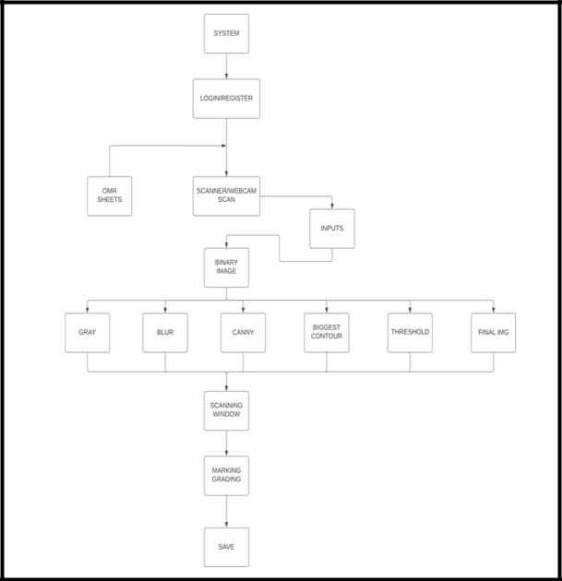

Figure No. 4.1 Architecture

7

**4.1.3Data Flow Diagram:**

**Level 0:**

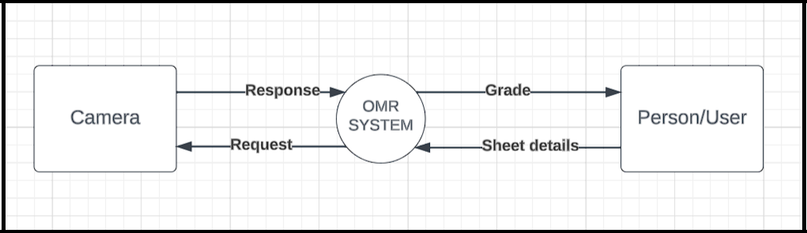

Figure No. 4.2 : DFD Level 0

**Level 1:**

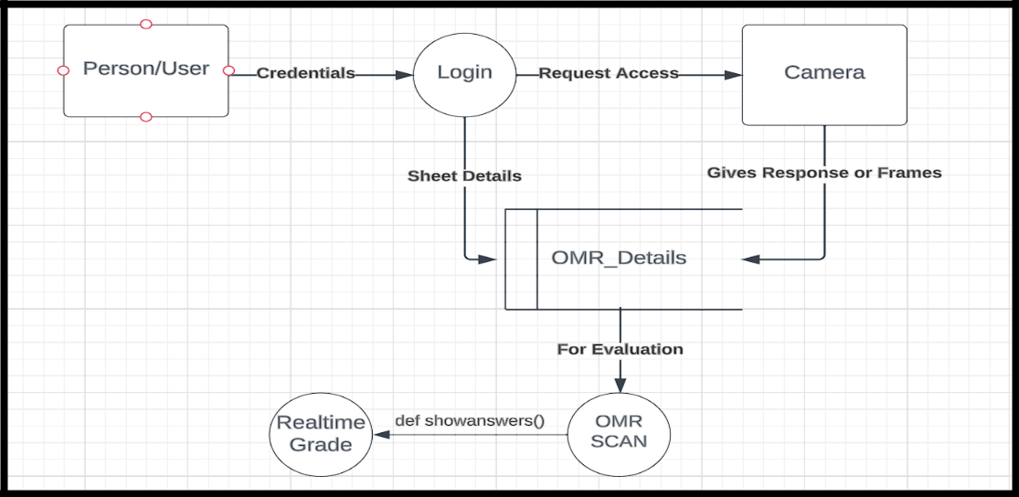

Figure No. 4.3 : DFD Level 1

8

**Level 2:**

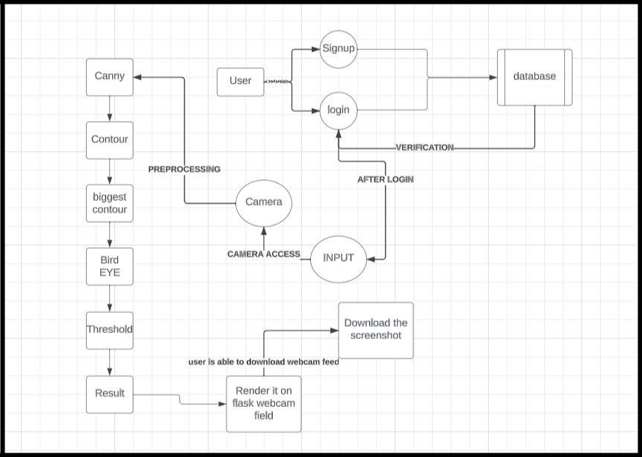

Figure No. 4.4 : DFD Level 2

9

**4.1.4 Use Case Diagram:**

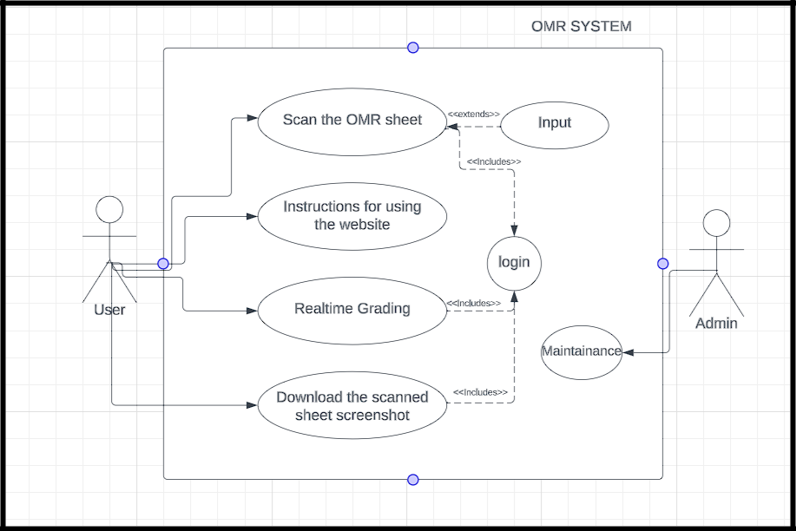

Figure No. 4.5 : Use Case Diagram

10

**4.1.5 Sequence Diagram:**

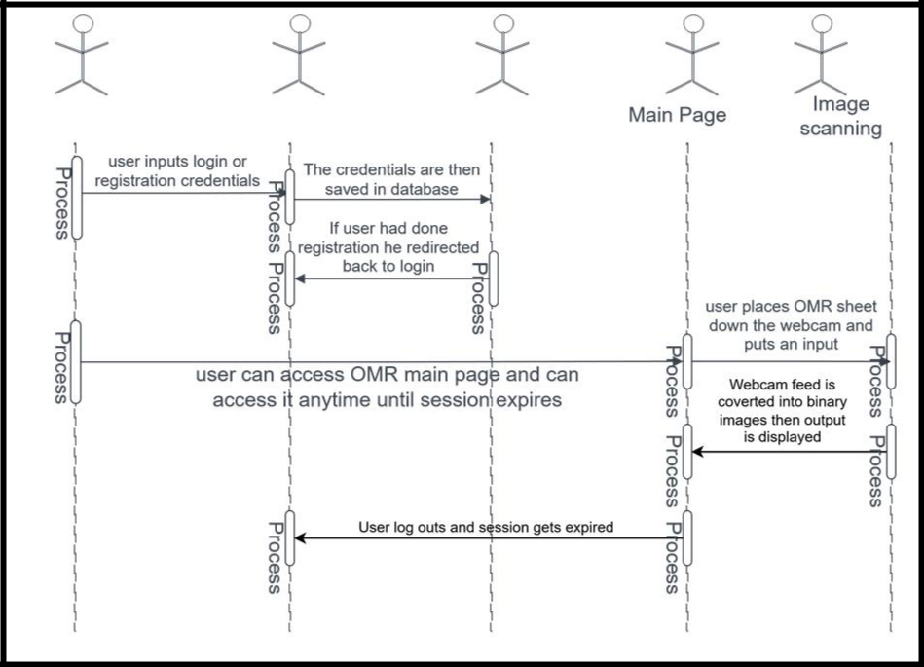

Figure No. 4.5 : Sequence Diagram

11

**4.1.6 Activity Diagram:**

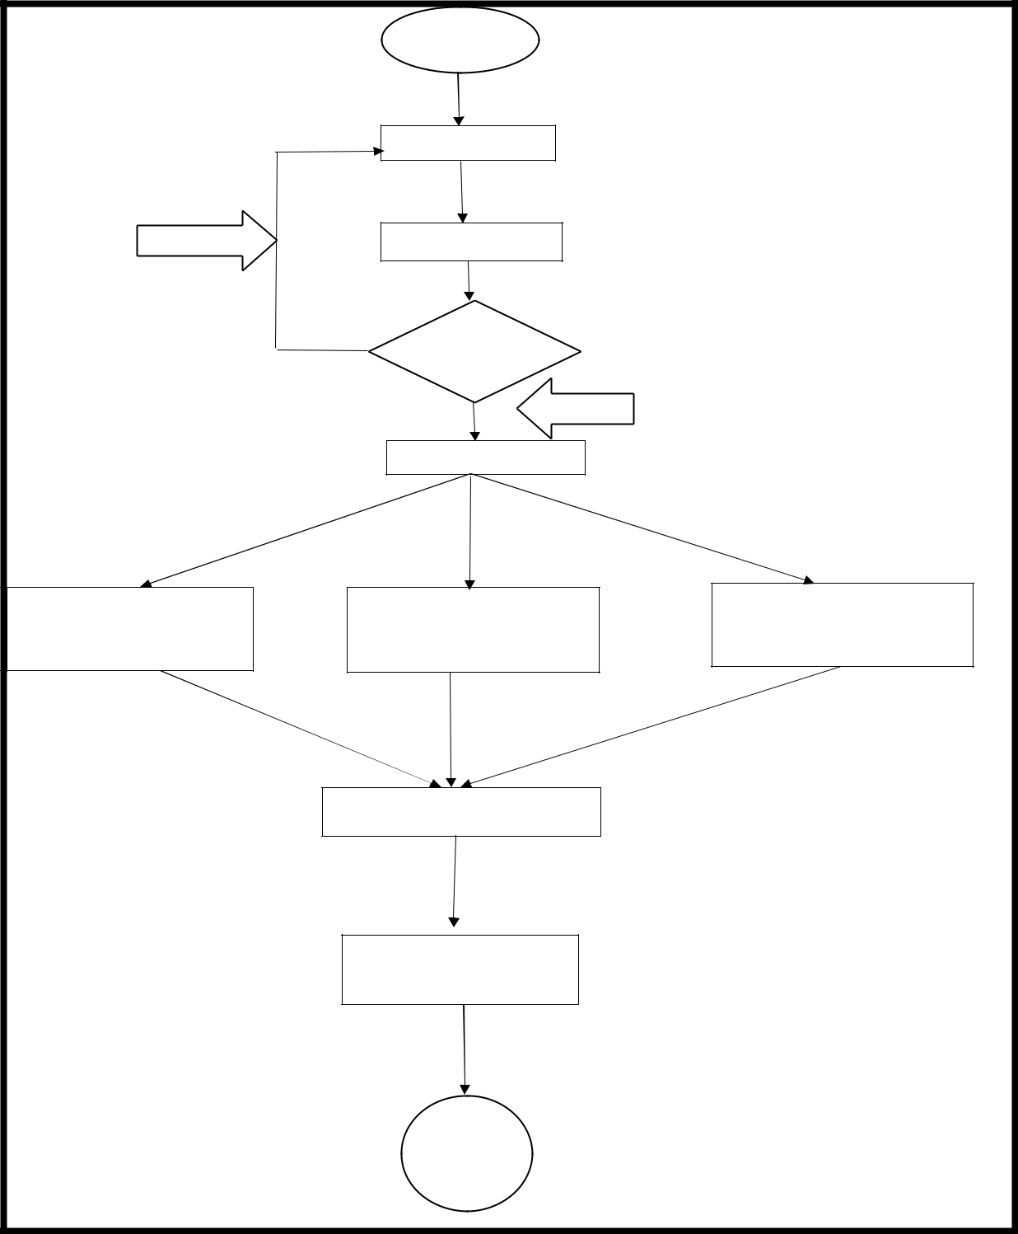

Figure No. 4.7 : Activity Diagram

12

**Chapter 5**

**Project Planning**

In the first week we have collected all the research paper , analyzed and enlisted the requirements of the project. Then we designed the frontend of the website. Then the Architecture, DFD’s and other diagrams were created. And then we started the actual backend of the application using python language. Various grading tests were performed on the tkinter shell before integrating the modules. After the testing integration of modules was done.

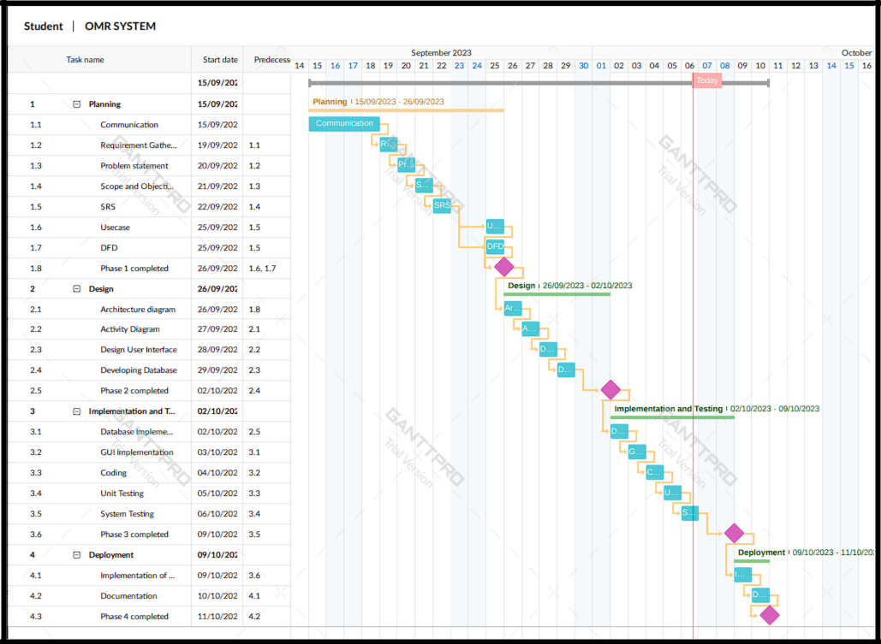

Figure No. 5.1 : Gantt Chart

13

**Chapter 6**

**Experimental Setup**

* **Software Requirements: -**

1.Python(cv2,MySQL connector,numpy,pyautogui,os)

2.Flask libraries(session,render_template,response,redirect,jasonify)

3.Mysql server and database “omr_logs”

4.Web browser

5.Working Webcam

6.Operating system

7.Text editor (Vscode or Pycharm)

* **Hardware Requirements:** -
  1. CPU: core i5
  2. RAM: 8.00 GB (7.68 GB usable)
  3. STORAGE: 512 GB
  4. PROCESSOR: 12th Gen Intel(R) Core (TM) i5-1235U 1.30 GHz
  5. OS: Windows
  6. INTERNET CONNECTIVITY: Medium

14

**Chapter 7**

**Implementation Details**

1)Installation steps:-

* Install any IDE supporting every language ( VScode , pycharm preffered )
* Install Python
* Create a Virtual Environment (optional but recommended)
* Install Flask(using pip install Flask)
* Inside the directory make a flask app using terminal

The Technology stack used to built the project’s backend are Python-(opencv , numpy , mysqlconnector) , for frontend – (HTML , CSS and Javascript)

The project is divided particularly in 3 modules

* 1. OMR-Sheet Scan
  2. Binary image processing and detect contours
  3. Grading the OMR detection
  4. Capture Virtual OMR sheet with grading(Screenshot)

1. **OMR - Sheet Scan:-**

So in this module it will capture the live video and generate frames. **Code Snippet** :-

.then(function(data) {

//Check the response from Flask if (data.login_successful) {

* + - Login was successful, execute your JS function or redirect to another page alert('Login successful! Now Please Insert your Inputs');

if (mainElement.style.display === "block" || mainElement.style.display === "") {

* + Hide .main and show .next mainElement.style.display = "none"; nextElement.style.display = "block";

} else {

* + Show .main and hide .next mainElement.style.display = "block"; nextElement.style.display = "none";

}

} else {

//Login failed, show an error message or take appropriate action alert('Login failed. Please check your credentials.');

}

15

})

.catch(function(error) {

console.error('Error:', error);

});

**(FUNCTION TO AUTHORIZE USER CREDENTIALS WHEN USER TRIES TO LOGIN)**

# Initialize the webcam

cap= cv2.VideoCapture(cameraNo)

cap.set(10,150)

def gen_frames():

while True:

success, img = cap.read()

if not success:

break

else:

# PREPROCESSING

img = cv2.resize(img, (widthImg, heightImg))

imgContours = img.copy()

imgFinal = img.copy()

imgBiggestContours = img.copy()

imgGray = cv2.cvtColor(img, cv2.COLOR_BGR2GRAY)

imgBlur = cv2.GaussianBlur(imgGray, (5, 5), 1)

imgCanny = cv2.Canny(imgBlur, 10, 50)

1. **Binary image processing and detect contours :-**

In this module Preprocessing of the captured frame is done. It identifies the biggest contour and stack the images , get the Bird-eye view of the biggest contour.

**Code Snippet** :-

def stackImages(imgArray,scale,lables=[]):

rows = len(imgArray)

cols = len(imgArray[0])

rowsAvailable = isinstance(imgArray[0],list)

width = imgArray[0][0].shape[1]

height = imgArray[0][0].shape[0]

if rowsAvailable:

for x in range (0, rows):

for y in range (0, cols):

imgArray[x][y] = cv2.resize(imgArray[x][y], (0,0), None , scale , scale)

if len(imgArray[x][y].shape) ==2: imgArray[x][y] =cv2.cvtColor

(imgArray[x][y], cv2.COLOR_GRAY2BGR)

imageBlank = np.zeros((height , width, 3), np.uint8)

16

hor = [imageBlank]*rows

hor_con = [imageBlank]*rows

for x in range(0, rows):

hor[x] = np.hstack(imgArray[x])

hor_con[x]= np.concatenate(imgArray[x])

ver = np.vstack(hor)

ver_con = np.concatenate(hor)

**For contour detection** :-

biggestContour = utilis.reorder(biggestContour)

gradePoints = utilis.reorder(gradePoints)

pt1 = np.float32(biggestContour)

pt2 = np.float32([[0, 0], [widthImg, 0], [0, heightImg], [widthImg, heightImg]])

matrix = cv2.getPerspectiveTransform(pt1, pt2)

imgWarpColored = cv2.warpPerspective(img, matrix, (widthImg, heightImg))

1. **Grading the OMR detection :-**

Here it detects the second biggest contour for grade box and according to the marks on the OMR it calculates and prints the percentage on the grade box.

**Code Snippet** :-

* GRADING grading = []

for x in range(0, questions): if ans[x] == myIndex[x]:

grading.append(1)

else:

grading.append(0)

* print(grading)

score = (sum(grading) / questions) * 100 # FINAL GRADE print(score)

**Displaying the answers virtually**:-

def showAnswers(img, myIndex, grading, ans, questions, choices):

secW = int(img.shape[1]/choices)

secH = int(img.shape[0]/questions)

for x in range(0, questions):

myAns = myIndex[x]

cX = (myAns*secW)+secW//2

cY = (x*secH) + secH//2

17

if grading[x] ==1:

myColor = (0,255,0)

else:

myColor = (0,0,255)

correctAns = ans[x]

cv2.circle(img, ((correctAns*secW)+secW//2, (x*secH)+secH//2), 15, (255,0,0), cv2.FILLED)

cv2.circle(img, (cX,cY), 30, myColor, cv2.FILLED)

return img

**d) Capture Virtual OMR sheet with grading(Screenshot):-**

User is able to download the screenshot of the webcam feed output along with the virtual marking and the grading with accuracy.

**Code Snippet** :-

captureButton.addEventListener('click', () => { // Get the user-entered file name

const customFileName = filenameInput.value || 'webcam_screenshot';

// Get the video container's dimensions

const containerWidth = document.getElementById('video-container').offsetWidth; const containerHeight = document.getElementById('video-container').offsetHeight;

* Create a canvas with the same dimensions as the video container const canvas = document.createElement('canvas'); canvas.width = containerWidth;

canvas.height = containerHeight;

const context = canvas.getContext('2d');

* Draw the video frame onto the canvas, cropping it to fit the container context.drawImage(video, 0, 0, containerWidth, containerHeight);
* Convert the canvas to a data URL

const dataURL = canvas.toDataURL('image/png');

* Create a download link with the custom file name const a = document.createElement('a');

a.href = dataURL;

a.download = `${customFileName}.png`;

18

**Chapter 8**

**Result**

* **LOGIN /SIGNUP :-**

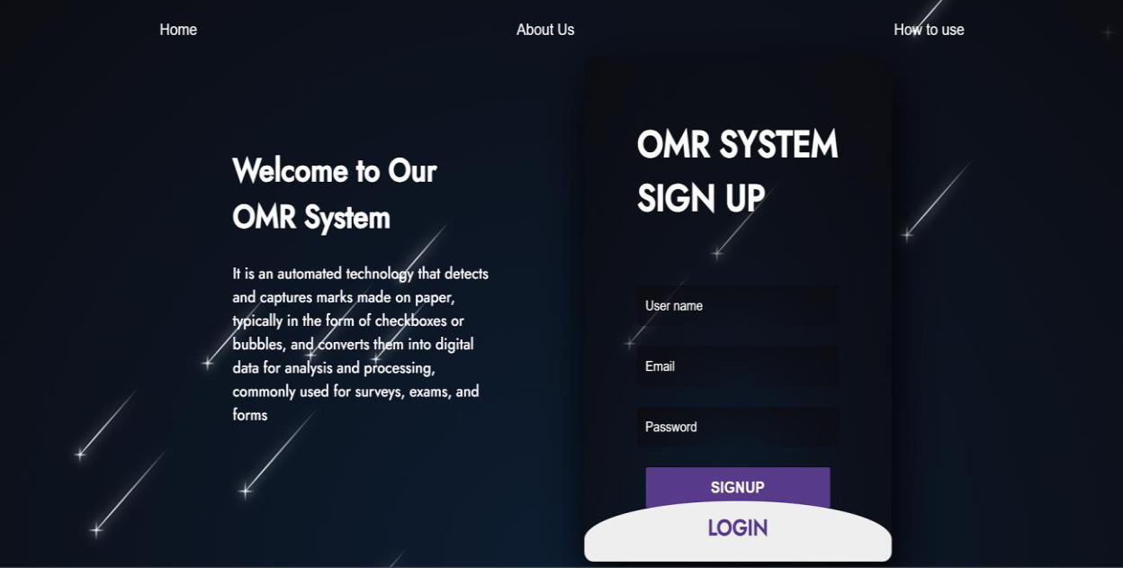

Figure No. 8.1 : LOGIN

**If The login Credentials don’t match with the signed up id it will display operation failed**

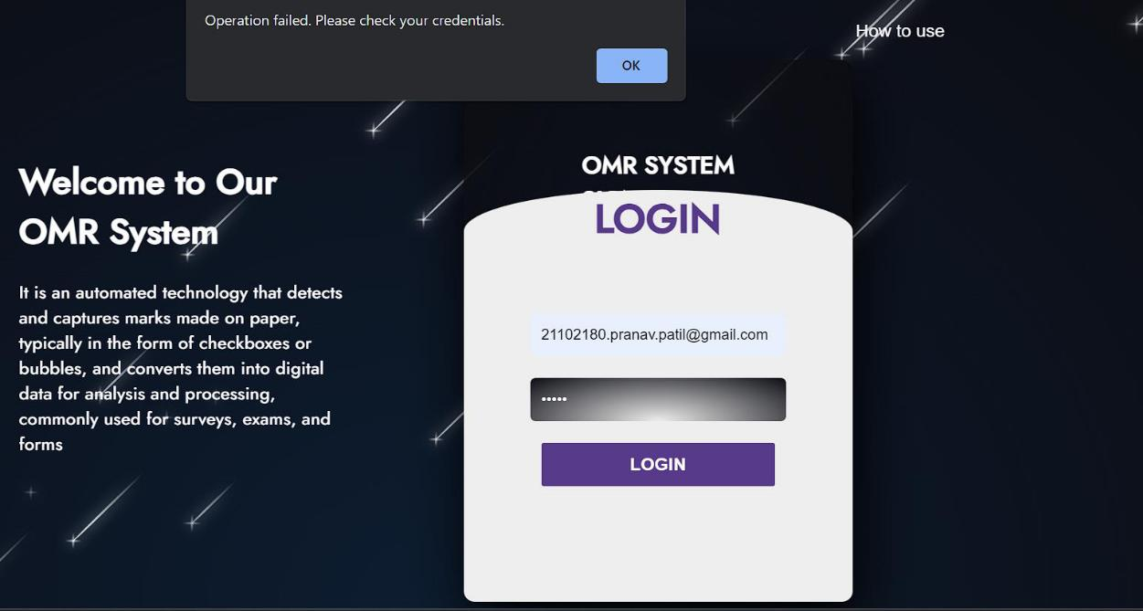

Figure No. 8.2 :SIGNUP

19

* **OMR Sheet Scan and Preprocessing in the back-end (Tkinter output) :-**

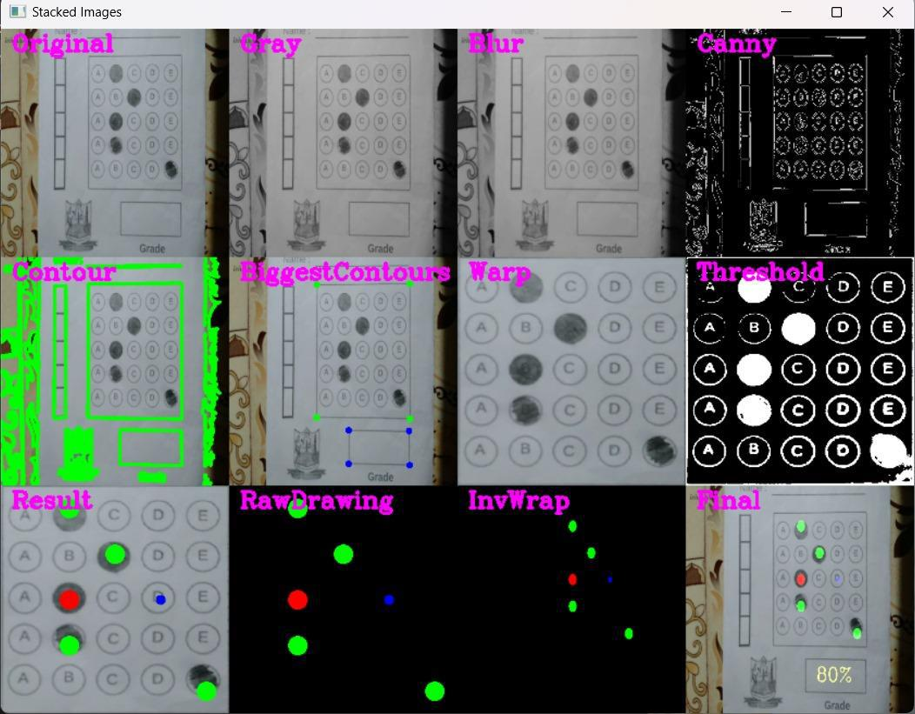

Figure No. 8.3 : Tkinter output

**TKINTER Final Scan Result :-**

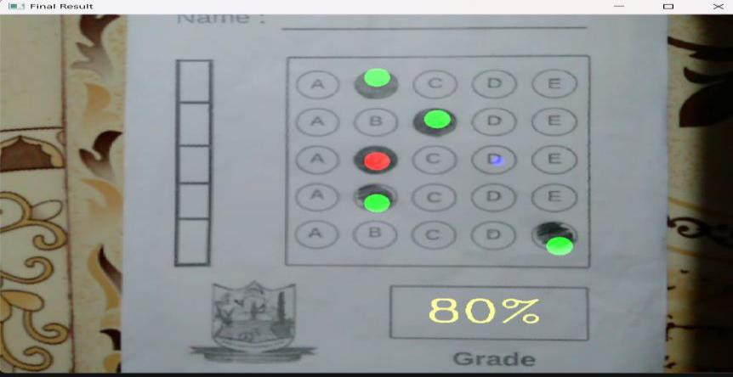

Figure No. 8.4 : TKINTER Final Scan Result

20

* **User-input :-**

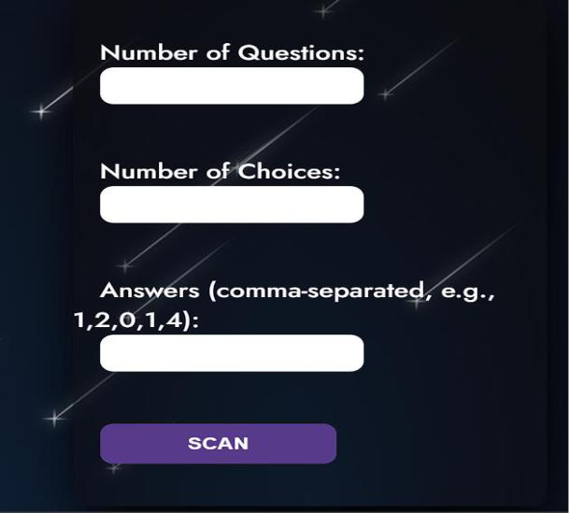

Figure No. 8.5 :User-input

**Download Webcam feed result:-**

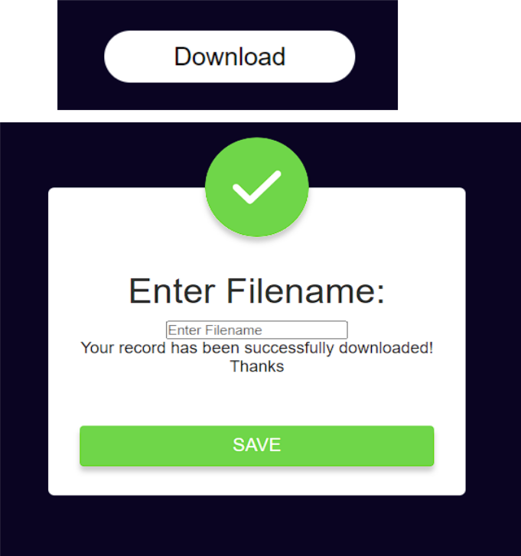

Figure No. 8.6 : Download Webcam feed result

21

* **How to use Page:-**

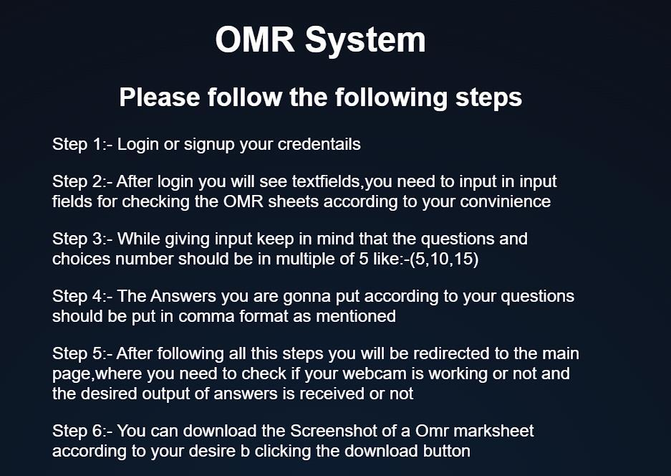

Figure No. 8.7 : How to use Page

22

**Chapter 9**

**Conclusion**

The OMR System is a revolutionary platform that has harnessed the power of modern technology to simplify and streamline the process of scanning, managing, and saving OMR (Optical Mark Recognition) data. By offering the unique capability to scan OMR sheets using mobile devices, webcams, and laptops, this website has transformed the way we approach data collection and result management.

The convenience and accessibility of OMR System have made it a game-changer for educators, exam administrators, and organizations seeking efficient data processing solutions. Whether you're a teacher conducting assessments in a classroom, an exam coordinator overseeing large-scale tests, or a business conducting surveys, this versatile system adapts to your needs.

Not only does OMR System provide the means to scan OMR sheets, but it also simplifies the result generation and storage processes. The ability to instantly view and save results, complete with detailed analytics, ensures that users can make informed decisions quickly. This is invaluable in educational institutions for timely assessment and feedback, and in businesses for data-driven decision-making.

In a world where efficiency and accuracy are paramount, the OMR System is the bridge between traditional data collection and modern technology. Its user-friendly approach, compatibility with various devices, and result management capabilities make it a pivotal tool for anyone dealing with OMR-based data. Embrace the OMR System and experience the future of OMR technology.

23

**References**

1. Daniel O'Connell (2011) O'Connell has conducted research on improving the accuracy of OMR systems, particularly in the context of educational testing. Look for papers related to OMR accuracy enhancement.
2. Jahan M. Dawlaty (2012). Dawlaty has contributed to research on using OMR technology in various fields, including healthcare and survey data collection. Search for his research on OMR applications.
3. Eric Saund (2015). Eric Saund has been involved in the development of OMR software and technology. Explore his work on OMR software systems and their features.
4. Richard J. Low (2019) Low's research has covered OMR security and privacy considerations. You can find his work related to OMR system security.
5. R. C. Tenny(2022) R. C. Tenny has published research on the challenges and future trends in OMR technology. Look for his contributions in this area

24